Research Study Participants Needed

Have you had a stroke?
Do you have problems moving your hands and fingers?
Find out if piano lessons can improve your hand and finger movements.

You may be eligible if you:
- Are an adult (over 18 years of age)
- Had a first time stroke more than 6 months but less than 2 years ago
- Have some ability to move your fingers
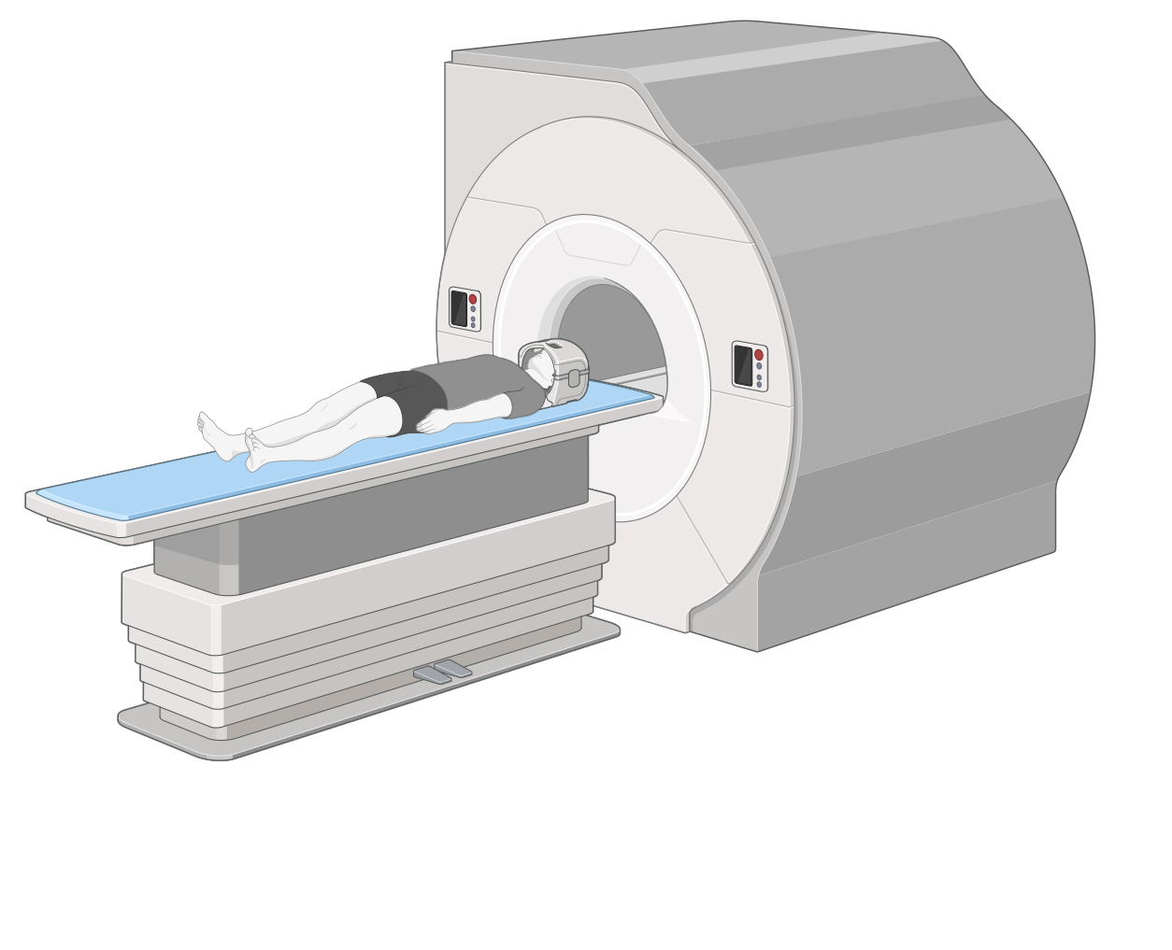
- Are eligible to undergo a magnetic resonance imaging (brain) scan
  - Do not have metal implants
  - Are not claustrophobic
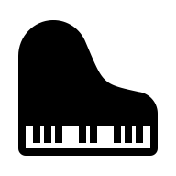
  - Are not pregnant

Your participation will require 14 visits total:
- 10 visits for piano lessons (individually and/or group):
  - 2 hours each day, 5 consecutive days, for 2 weeks.
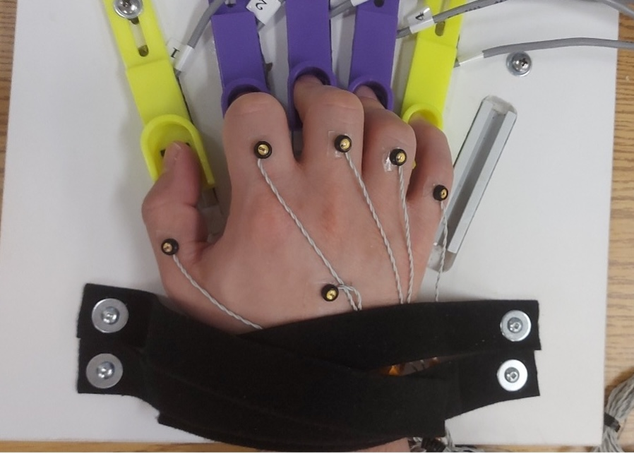
- 4 visits where we will evaluate how you move: 1 visit before and 3 visits after the piano lessons. Each visit is approximately 2 to 3 hours
  - Includes 2 magnetic resonance imaging (brain) scans, approximately 1 hour each.

The research study will take place at:
- Faculty of Kinesiology and Physical Education, University of Toronto
55 Harbord St. (by Spadina Ave.)

For more information:
- Please contact Dr. Joyce Chen at joycelynn.chen@utoronto.ca or the research team at kpe.tempolab@utoronto.ca

